



Fraud Detection
-Ajesh Chavan

Agenda
- Introduction to Fraud Detection
- Problem Statement & Business Objective
- Dataset Overview
- OVERALL PROJECT WORKFLOW (Diagram)
- Data Preprocessing Approach
- Exploratory Data Analysis (EDA)
- Feature Engineering
- Machine Learning Models Used
- Model Evaluation & Final Selection
- End-to-End System Architecture
- Deployment Strategy
- Results & Business Impact
- Challenges Faced & Solutions
- Future Enhancements
- Conclusion

1. Introduction to Fraud Detection
Fraud detection is the process of identifying suspicious or unauthorized financial transactions.
With the rapid growth of online banking, UPI, and digital payments, fraud cases have increased significantly.
Manual fraud detection is no longer effective because:
- The number of transactions is very large
- Fraud patterns are complex and constantly changing
Machine learning helps automate fraud detection by learning patterns from historical transaction data and identifying abnormal behavior in real time.

2. Problem Statement & Business Objective
Problem Statement
Financial institutions process millions of transactions every day.
Even a small percentage of fraud can lead to:
- Huge financial losses
- Customer dissatisfaction
- Loss of trust
Traditional rule-based systems are slow and not scalable.
Business Objective
The objective of this project is to:
- Detect fraudulent transactions accurately
- Reduce financial loss
- Minimize false alerts for genuine users
- Enable fast, real-time decision making

3. Dataset Overview
The dataset used in this project represents financial transaction data.
Key points:
- Each row represents one transaction
- Features include transaction amount, balances, transaction type, and time
- Target variable:
  - isFraud = 1 → Fraudulent transaction
  - isFraud = 0 → Legitimate transaction
The dataset closely simulates real-world banking transactions.

SLIDE 4: OVERALL PROJECT WORKFLOW (Diagram)
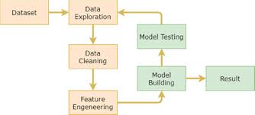

Overall Project Workflow
- Data collection and understanding
- Data preprocessing
- Exploratory data analysis
- Feature engineering
- Model training and evaluation
- Model deployment
Fraud prediction and alert generation
5. Data Preprocessing Approach
Before building the model, the data was preprocessed to make it suitable for machine learning.
Steps performed:
- Checked for missing and inconsistent values
- Encoded categorical features such as transaction type
- Scaled numerical features
- Removed unnecessary identifier columns
Why this step is important:
Machine learning models work best with clean, numerical, and well-structured data.

6. Exploratory Data Analysis (EDA)
EDA was performed to understand transaction behavior and fraud patterns.
Key insights:
- Fraud transactions are very rare compared to genuine ones
- The dataset is highly imbalanced
- Most fraud occurs in:
  - TRANSFER
  - CASH-OUT transactions
- Fraud transactions usually involve:
  - High transaction amounts
  - Sudden balance reduction
📊 ADD YOUR GRAPHS HERE:
- Fraud vs Non-Fraud distribution graph
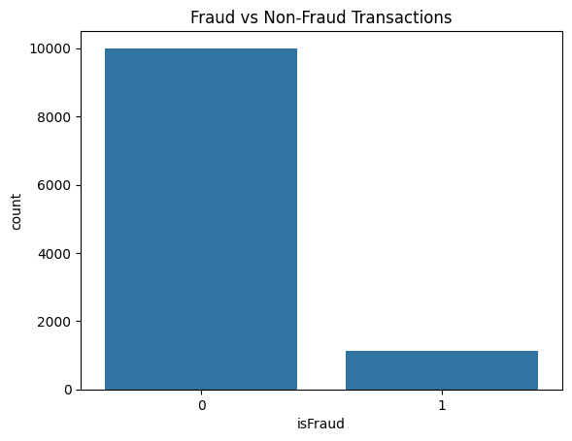

- Transaction Type vs Fraud graph
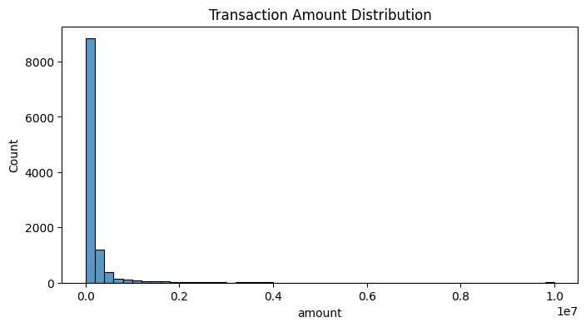
These graphs visually justify why fraud detection is a challenging problem.

7. Feature Engineering
Feature engineering was done to improve model performance.
Important engineered features:
- Balance difference between old and new balance
- Identification of high-risk transaction types
Why feature engineering is needed:
It helps the model capture hidden fraud patterns that are not directly visible in raw data.

8. Machine Learning Models Used
Two models were implemented:
- Logistic Regression
  - Used as a baseline model
  - Simple and interpretable
- Random Forest Classifier
  - Handles complex, non-linear patterns
  - Performs well on imbalanced data
  - Commonly used in fraud detection systems
Random Forest performed better and was selected for further tuning.

9. Model Evaluation & Final Selection
Evaluation Metrics Used:
- Precision – how accurate fraud predictions are
- Recall – how many actual frauds are detected
- F1-Score – balance between precision and recall
- ROC-AUC – overall model performance
Recall was prioritized because missing fraud is more costly than false alerts.
Final Model:
- Random Forest with SMOTE
- High recall
- Stable and business-friendly performance
📊 ADD YOUR GRAPHS HERE:
- Feature Importance graph
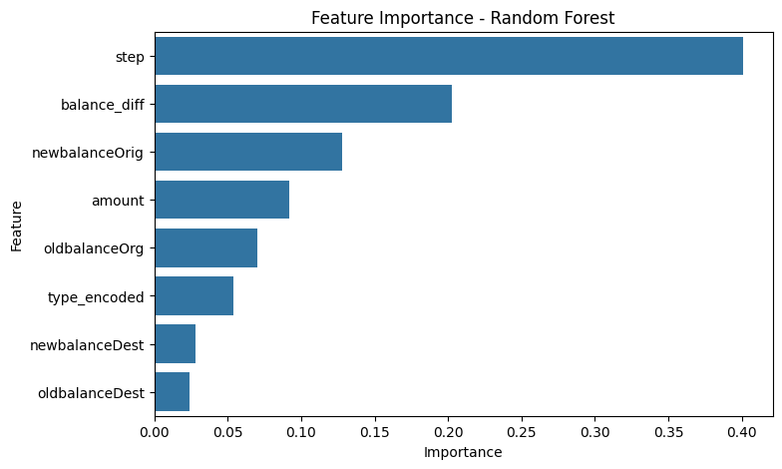
- Confusion Matrix
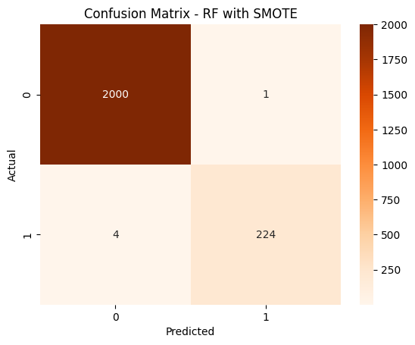
- (Optional) ROC curve or metrics screenshot
These graphs explain model performance and decision logic.
10. End-to-End System Architecture
The complete system works as follows:
- Transaction data is received
- Data is preprocessed and scaled
- The trained ML model predicts fraud probability
- A threshold is applied
- Transaction is classified as Fraud or Legitimate
- Alerts are generated if fraud is detected
This ensures smooth end-to-end fraud detection.

11. Deployment Strategy
The final model was deployed as a web application using Streamlit.
Deployment features:
- User enters transaction details
- Model predicts fraud probability in real time
- Risk level is displayed (High / Medium / Low)
- Explanation of prediction is provided
- PDF fraud report can be downloaded
📊 ADD SCREENSHOTS HERE:
- Streamlit app UI
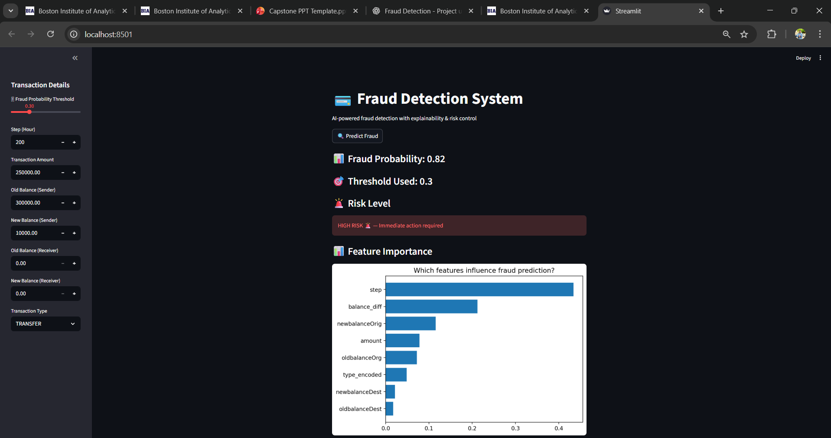
- PDF report output
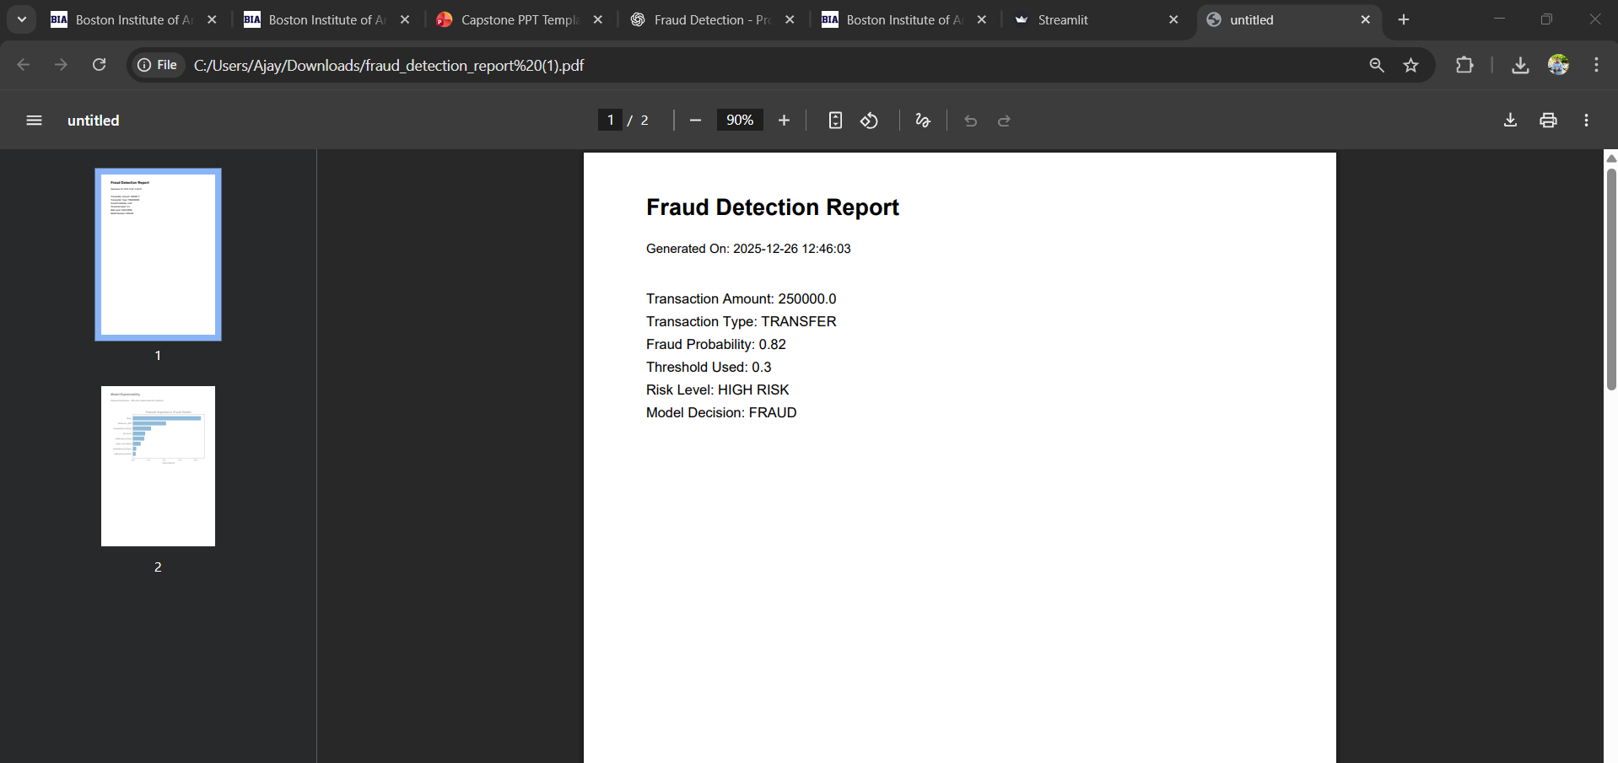
This proves the project is fully implemented and deployable.
12. Results & Business Impact
Results:
- Improved fraud detection performance
- High recall ensured fewer fraud cases were missed
- Better model reliability
Business Impact:
- Reduced financial loss
- Faster fraud response
- Improved customer trust
- Supports audit and compliance teams

13. Challenges Faced & Solutions
Challenges:
- Highly imbalanced dataset
- Risk of missing fraud cases
- Need for explainable predictions
Solutions:
- Used SMOTE to handle imbalance
- Focused on recall instead of accuracy
- Added feature importance and AI explanations

14. Future Enhancements
Possible future improvements include:
- Deep learning–based fraud detection
- Real-time transaction streaming
- Cloud deployment (AWS / Azure)
- Advanced explainability using SHAP
- Integration with banking APIs

15. Conclusion
This project demonstrates a complete end-to-end fraud detection system.
Key highlights:
- Real-world business problem solved
- Full data science lifecycle covered
- Deployed and explainable ML solution
- Industry-ready and interview-ready project



Thank You.
I would be happy to answer any questions ?

Thank You!

